Care Companion

Developed by

Team Kshemangkari
Care that never sleeps
ABSTRACT
CareCompanion is a service robot designed to support the elderly and patients in managing their daily routines. The robot assists by identifying medicines, reminding users of schedules, and monitoring basic health parameters through integrated sensors. It is built with an ESP32 micro controller, a camera module, and additional sensors for accurate detection and user interaction. The robot is programmed to recognize different medicines using computer vision and to provide real-time alerts via Bluetooth. Throughout development, several design iterations were made to improve stability, accuracy, and userfriendliness. Testing demonstrates that CareCompanion can accurately identify medications and issue reminders with high reliability. This project demonstrates the potential of robotics to enhance independent living, reduce caregiver workload, and promote healthier lifestyles through the use of accessible and affordable technology.

Problem Statement
As populations age and the number of patients requiring daily medical attention increases, many elderly people struggle to manage their medicine schedules and basic health monitoring without constant assistance. Forgetting to take medicines, confusing doses, or missing reminders can lead to serious health risks.Caregivers and family members often face challenges in providing continuous support, especially when balancing other responsibilities. There is a need for an affordable, user-friendly, and reliable solution that helps patients and elderly people manage their daily healthcare routines independently, while reducing the workload on caregivers.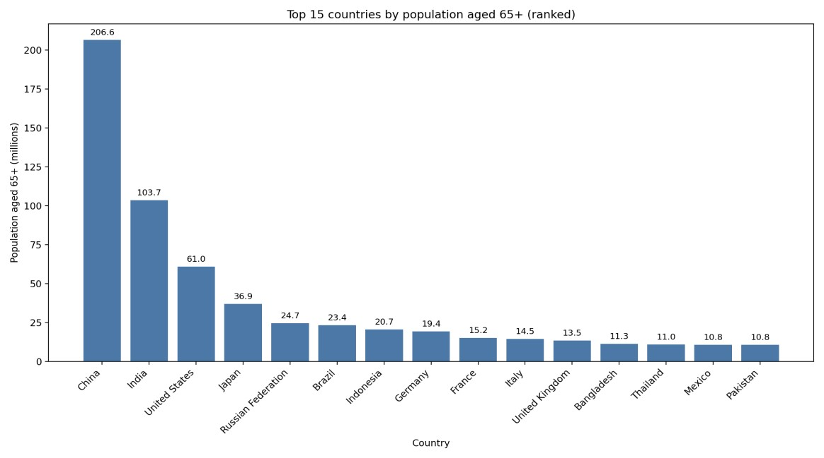

Aebong's grandmother fell in the bathroom and was seriously injured.She often take one medicine twice. Sometimes she even forgets to take her medicine timely. Her recovery was complicated by a daily medication she often forgot to take. We realized that many elderly people face similar challenges with health monitoring and medication management. This inspired us to create a solution.We envisioned a smart assistive stick that could help elderly people with their daily health needs. We named our idea CareCompanion. The stick would allow users to check their pulse, receive timely alerts for their medication, and even help them identify the correct medicine to take. Our goal is to use technology to provide a simple yet effective tool for seniors to manage their health and well-being.

Key Factors we focused on this project are given below-
- Medicine Identification – Detect and recognize different medicines using computer vision to help users avoid confusion.
- Reminder System – Provide timely reminders for medicine intake and health checkups.
- Health Monitoring – Record and track basic health parameters (such as temperature, heart rate, or other sensor inputs).
- User-Friendly Interaction – Ensure easy communication with the user through simple alerts, display, or Bluetooth notifications.

Reason for Choosing this Problem
Elderly people around us often forgets to take their medicines on time. Besides they often gets confused which is the right medicine. In this way they sometimes take the wrong medicine as well. Sometimes they even forget to take their medicines. This is really harmful for their health. Elderly people often pass away for this reason. Family members and others don’t really give importance to this matter. Not only in Bangladesh but also elderly people living in countries all around the world suffers this problem. For this reason the elderly people needs someone who will help them in their need. So we came up with this Smart Assistive Stick to make the life of elderly people more easier , helpful and peaceful.

Robotic Solutions
Our smart assistive stick has pulse sensor-MAX30102 which allows elderly people to measure their pulse. It also have a Inertial Measurement Unit sensor - MPU6050 which helps to detect falls. It also have GPS for tracking location. For AI based medicine Detection, we used Huskylens AI Camera. This camera allows users to detect and recognize any tag attached to the medicine. This camera will help elderly by detecting the right medicine from the bundle. Like if an elderly person is suffering from fever and he has two medicines in front, the Ai Camera will observe which is the correct one and then send a audible signal which will indicate proper medicine is taken and also show the message in camera display. In this way our smart Assistive stick will help the elderly people through robotics and ICT.

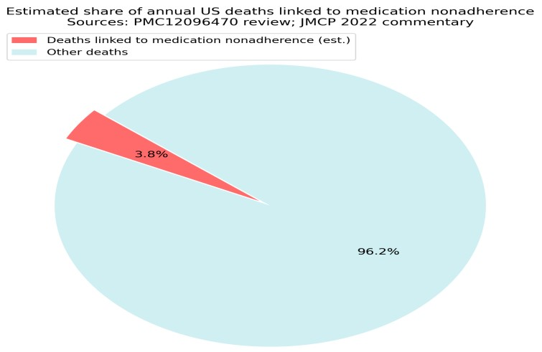
Medication nonadherence is a significant contributor to mortality, particularly among older adults. In the United States, it is estimated that medication nonadherence leads to approximately 125,000 deaths annually, which represents a substantial portion of preventable deaths related to chronic diseases. Systematic reviews indicate that nonadherence can account for 30-50% of chronic disease treatment failures, and it
is associated with a 25% increase in all-cause mortality.
While specific percentages of deaths attributable to nonadherence in older adults are not detailed in the provided contexts, the overall impact of nonadherence on mortality is
well-documented, highlighting the urgent need for improved
adherence strategies to mitigate these risks.
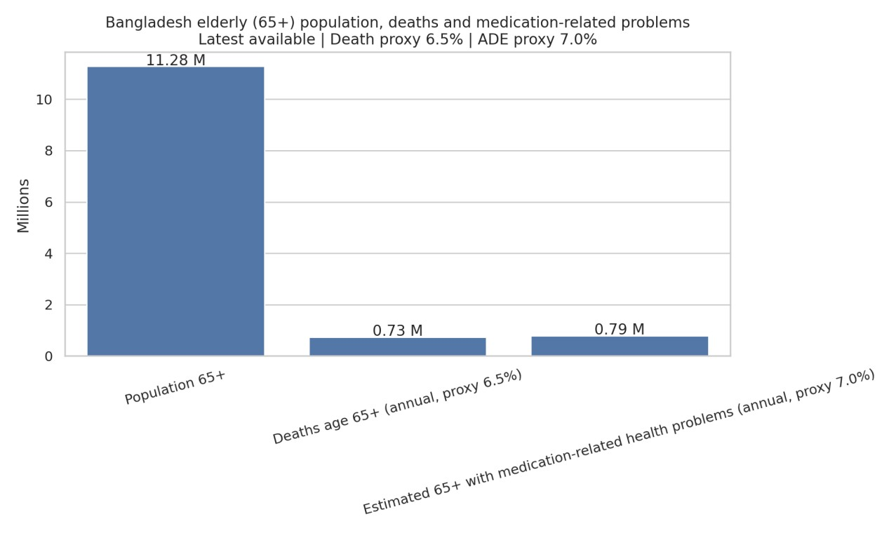
The graph uses three bars to represent the following:
Population 65+: The first and largest bar shows the total population of elderly people (aged 65 and over) in Bangladesh, which is 11.28 million. This is your target demographic.
Deaths age 65+ (annual, proxy 6.5%): The second bar represents the estimated number of annual deaths among this elderly population. Based on a proxy death rate of 6.5%, this figure is 0.73 million deaths per year. This highlights the mortality rate within your target group, which is a critical consideration for a care-providing robot.
Estimated 65+ with medication-related health problems (annual, proxy 7.0%): The third bar shows the estimated number of elderly people who experience health problems related to medication. With a proxy rate of 7.0%, this figure is 0.79 million people annually. This is particularly relevant to the CareCompanion project, as it underscores a significant need for medication management and assistance.
Relevance to the CareCompanion Project:
Market Size: The 11.28 million elderly population is the total potential market for your robot. This is a substantial and growing demographic, indicating a strong market opportunity.
Need for Medication Management: The 0.79 million people with medication-related problems highlight a specific and critical problem that our CareCompanion robot can address. This is a clear justification for features like medication reminders, dosage tracking, and warning systems.
Healthcare Support: The data on deaths and medication problems collectively demonstrates the significant healthcare challenges faced by the elderly in Bangladesh. A robot like CareCompanion could play a vital role in improving health outcomes, providing support to families and caregivers, and potentially reducing health complications.

Key Features
- Health and Medicine Management: It assists users in managing their daily routines, including identifying medicines, providing schedule reminders, and monitoring basic health parameters.
- Integrated Sensors: It uses a camera module, an ESP32 microcontroller, and other sensors for accurate detection and user interaction.
- Computer Vision: The robot is programmed to recognize different medications using computer vision.
- Real-time Alerts: It provides real-time alerts to the user, likely via Bluetooth.
- Safety Features: It includes a GPS module and an accelerometer/gyroscope (MPU6050) for fall detection, and an emergency alert system that can send SMS and email notifications to caregivers.

Value of our Solution
- Promotes Independence: The robot enables elderly individuals and patients to manage their daily routines, such as taking medicine and monitoring their health, on their own. This reduces their reliance on others and supports independent living.
- Enhances Safety: By providing timely medicine reminders and using computer vision to identify pills, the robot helps users avoid missing doses or taking the wrong medication, which can lead to serious health risks. Additionally, the inclusion of a GPS module and an accelerometer/gyroscope (MPU6050) for fall detection adds a crucial safety net for emergencies.
- Reduces Caregiver Burden: The robot takes over routine tasks like medicine reminders and health monitoring, which frees up caregivers and family members to focus on other responsibilities. This provides peace of mind for both the user and their family.

Real-Life Implementations of our project
- In-Home Assistance: The most direct application is in private homes, where it can be used as a personal companion for the elderly living alone. Its portable, stick-like design makes it easy for a user to place it on a desk or carry it with them throughout the day.
- Assisted-Living Facilities: CareCompanion could be implemented in assisted-living homes to supplement the work of staff. Instead of staff members manually checking on every resident's medicine schedule, the robot could handle automated reminders for a group of residents, allowing staff to focus on more complex care needs.
- Hospital and Clinic Use: The robot's ability to track and record basic health parameters like heart rate and oxygen saturation (SpO₂) makes it useful in clinical settings. A patient's health data could be logged automatically, providing doctors with a more complete picture of their vitals over time.
The GPS module could also be used to track patients' movement within a large hospital ward for safety purposes.

Limitations of our project
- Native App Support: As this device is under development, the entire system is built on an open-source development platform like Arduino IoT Cloud which allows limited access and scheduling for unlocking the full potential, the device will need a dedicated server and real time database system which will e interacted with an app.

Components used in our project

1. ESP32
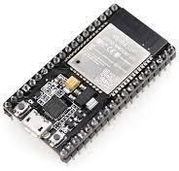
Explanation: The ESP32 is a low-cost, low-power system on a chip (SoC) that integrates Wi-Fi and Bluetooth capabilities. It's an incredibly versatile microcontroller often used in Internet of Things (IoT) applications due to its connectivity features and dual-core processing. As the "brain" of the robot, the ESP32 is responsible for processing data from all sensors, making decisions about the robot's actions (e.g., navigation, alerts), and controlling the motors. Its built-in Wi-Fi and Bluetooth allow for remote monitoring by a caregiver or family member, enabling real-time data transfer and control commands.

2. MPU6050(Accelerometer & Gyroscope)
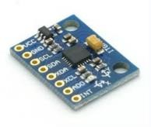
Explanation: The MPU6050 is a 6-axis motion tracking device that combines a 3-axis accelerometer and a 3-axis gyroscope. The accelerometer measures linear acceleration, while the gyroscope measures angular velocity (rotation).This and tilt, which is essential for stable movement on different surfaces. For instance, if the robot tilts too far while moving, the MPU6050 data can trigger a response from the ESP32 to adjust motor speeds and prevent the robot from tipping over. It can also detect falls or sudden, unusual movements of the robot, potentially indicating a problem.

- MAX30102 (Pulse Oximeter & Heart Rate Sensor)
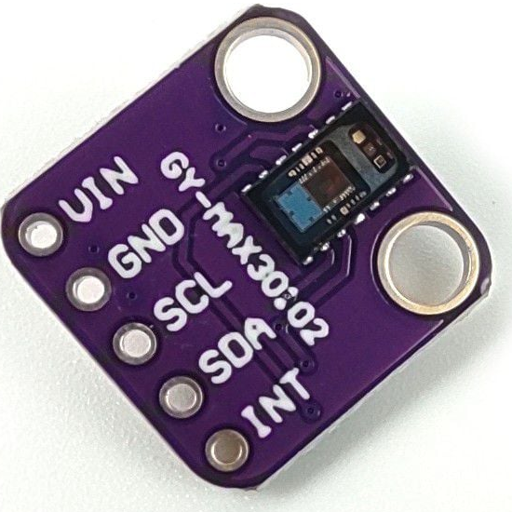
The MAX30102 is a biomedical sensor that uses red and infrared LEDs to measure the absorption of light through the skin, which allows it to determine blood oxygen saturation (SpO2) and heart rate.This component provides a basic health monitoring function. When the user places their finger on the sensor, the robot can take a reading of their heart rate and oxygen levels. This data can be displayed on the OLED screen and, importantly, sent to a remote caregiver via the ESP32's WiFi. This allows for simple, non-invasive health checks and alerts in case of abnormal readings.

- OLED Display (0.96 inch)
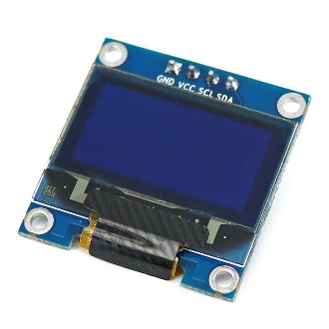
Explanation: An OLED (Organic Light-Emitting Diode) display is a type of screen that is known for its high contrast and low power consumption. This specific 0.96-inch model is compact and ideal for small electronics projects. The OLED display serves as the primary user interface for the person interacting with the robot. It can show real-time sensor readings from the MAX30102, display text reminders for medication, or show status messages for the robot (e.g., "Finding GPS signal" or "Medication dispensed").

5. HuskyLens 2MP AI Camera
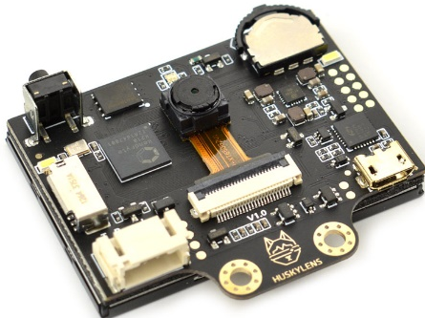
Explanation: The HuskyLens is an AI vision sensor with pretrained vision algorithms. It can perform functions like object recognition, face recognition, color detection, and line tracking without needing complex programming on the main microcontroller. This is one of the most advanced components of the project. It enables the robot to recognize and identify medicine bottles, a key function for reminding users to take their medication. It can also use face recognition to greet a specific user or a caregiver. Its object and color detection capabilities could be used for advanced navigation and interaction with the environment.

6.SIM800L GSM Module
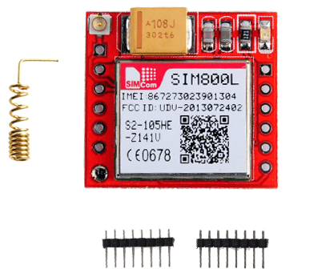
Explanation: The SIM800L is a compact GSM Module that features SMS sending and making a call. It can used for emergency location sending and directly call someone if the patient presses the Panic Button

7.GY-NEO6MV2 GPS Module
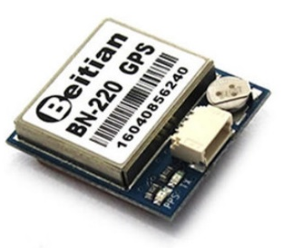
Explanation: Beitian BN-220 is a super-small, lightweight dual-GNSS module widely used in FPV drones, RC planes, and microcontroller projects. It supports multiple satellite systems including GPS and GLONASS for fast locks and reliable positioning. This module is extremely compact but powerful enough to find the location. This is crucial for several safety and navigation features. It can be used for geofencing, alerting a caregiver if the robot (and potentially the user with it) moves outside a predefined safe zone. It can also be used for advanced navigation, allowing the emergency to reach out if necessary.
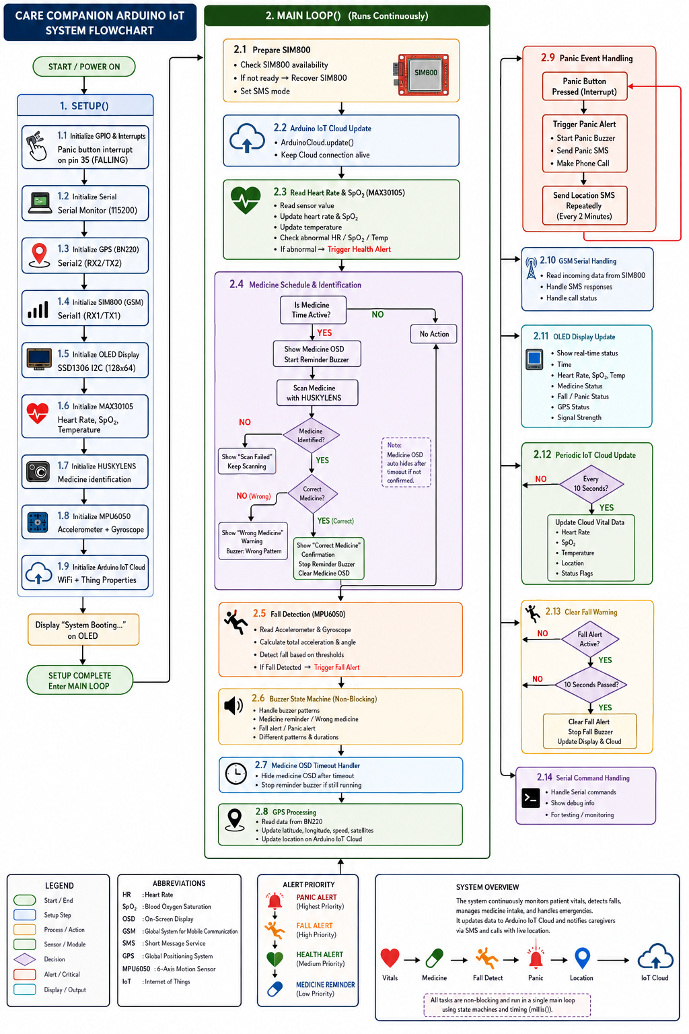
Flowchart

Mechanical Structure and Circuit Diagram
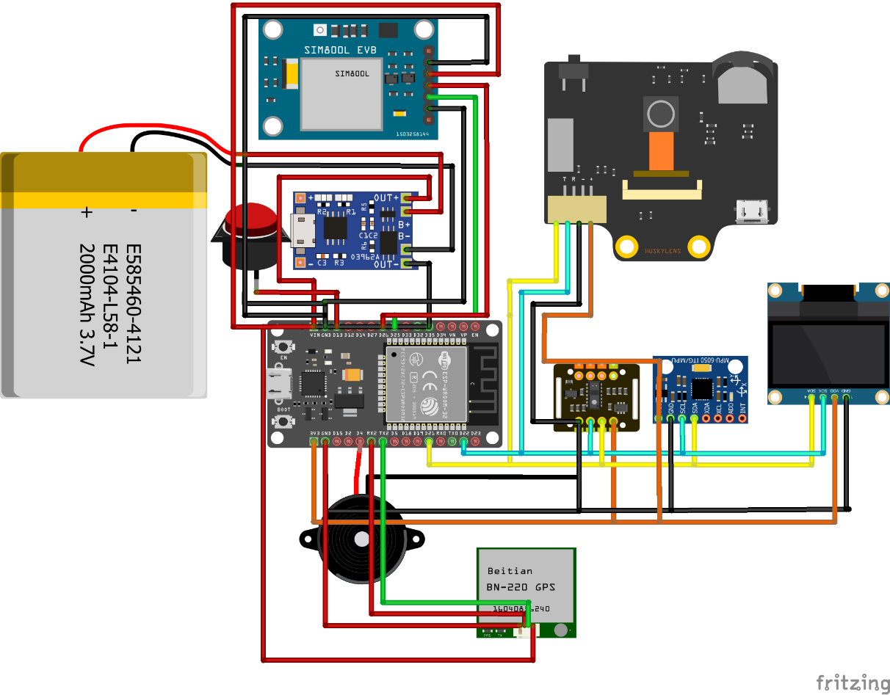

Pseudocode
System Setup and Main Loop Operation
1. Setup Phase
The setup phase initializes all hardware modules, communication interfaces, sensors, and system services required for the device to operate.
Step | Module / Function | Action
1 | Serial Monitor | Set up the Serial Monitor and initialize I²C communication using GPIO 21 (SDA) and GPIO 22 (SCL).
2 | OLED Display | Initialize the OLED display. If the OLED is not detected, stop program execution.
3 | GPS Module | Start the GPS serial communication using GPIO 16 (RX) and GPIO 17 (TX).
4 | Heart Rate Sensor | Initialize the MAX30102 heart-rate sensor. If the sensor is not detected, stop program execution. The IR LED is turned ON, while the Red and Green LEDs remain OFF.
5 | MPU6050 Gyroscope | Initialize the MPU6050 accelerometer and gyroscope. If the connection fails, print an error message to the OLED Display.
6 | SIM800L | Initialize the SIM800L with Hardware Serial and do custom AT command to make calls and SMS
7 | Buzzer | Configure the buzzer pin as an OUTPUT and keep the buzzer initially turned OFF.
8 | Wi-Fi | Connect to Wi-Fi using the configured SSID and password. Start connecting with Arduino IoT Cloud with proper credentials retrying until a successful connection is established.
9 | HuskyLens | Initialize the HuskyLens camera/tag detector. Continue attempting to connect until the HuskyLens connection is successful.

2. Main Loop
After the initial setup is complete, the system continuously executes the following operations inside the main loop. The loop monitors the user's heart rate, movement, medication schedule, GPS position, and medication identification while providing visual, audible, and wireless feedback.
Step | Module / Function | Action
1 | NTP Synchronization & BPM Buffer | Maintain NTP time synchronization and initialize the BPM averaging buffer before beginning the main monitoring cycle.
2 | OLED & GPS | Display current heart-rate info on the OLED. Continuously read incoming GPS data; mark status as valid if available, otherwise store as invalid.
3 | Heart Rate Monitoring | Read MAX30102 IR values (finger present if IR > 20,000). Calculate and update average BPM.  • Buzzer ON: If average BPM < 50 or > 100.  • Buzzer OFF: Otherwise.
4 | MPU6050 Fall Detection | Read accelerometer/gyroscope values to calculate total acceleration and tilt angle.  • Fall Detected: If thresholds are met, sound buzzer alert for 2 seconds.  • No Fall: Resume standard monitoring.
5 | OLED, Time & Medication Alarm | • OLED: Shows BPM (or "---" if invalid); alternates between GPS coordinates and gyroscope data.  • Time/BT: Fetches NTP time, outputs to Serial/Bluetooth. Listens for "alarm:HH:MM" commands.  • Alarm Trigger: Plays 2-sec buzzer alert when scheduled time arrives.  • Missed Dose: If no medication is detected within 60 seconds, marks flag as triggered and repeats buzzer alerts until resolved.  • Calls HuskyLens_Check() before ending loop.
6 | HuskyLens Medication Detection | Requests object recognition data via HuskyLens_Check():  • ID 1 (Correct): Prints "Proper medicine recognized?" and plays a confirmation sound.  • Other ID (Wrong): Prints "Wrong medicine" and plays an error sound.  • No Tag Learned: Reports nothing learned.

3. Overall System Operation
The system continuously monitors several conditions simultaneously, including heart rate, fall detection, GPS position, medication timing, and medication identification. Sensor readings are displayed through the OLED, while important events such as abnormal heart rate, falls, and medication reminders trigger the buzzer and audio alerts.
The medication workflow combines the NTP-synchronized clock, Bluetooth alarm scheduling, buzzer/MP3 alerts, and HuskyLens tag recognition. This allows the system to remind the user when medication is due and subsequently verify whether the correct medication has been identified.

MPU6050 Accelerometer/Gyroscope
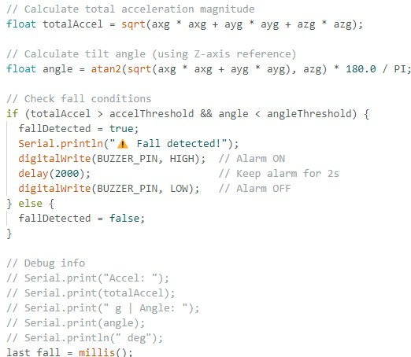
This code snippet is the core of a fall detection system, which uses an accelerometer and gyroscope to determine if a person has fallen. It works by monitoring two key values: the total acceleration and the tilt angle.The code checks if both conditions for a fall are met: a sudden high acceleration (indicating an impact) and a low tilt angle (meaning the device is now flat). If these conditions are true, it triggers a buzzer alarm for two seconds to alert others. If the conditions are not met, no alarm is sounded. This approach helps prevent false alarms by looking for a specific, two-part pattern of motion.

Bluetooth and NTP Client
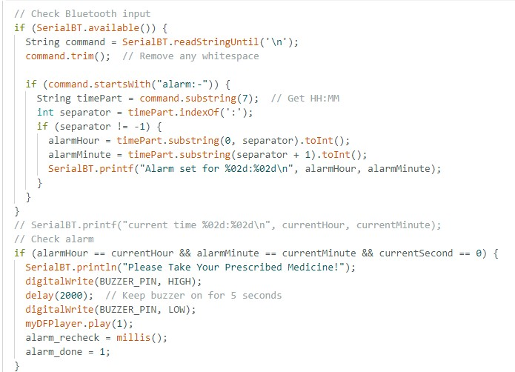
This code snippet handles the medication alarm functionality of the smart walking stick. It performs two main tasks:
Setting the Alarm: It constantly checks for incoming messages from a connected Bluetooth device. If it receives a command that starts with _{"alarm:-"}, it parses the message to extract the hour and minute, then stores this time as the alarm time. For example, receiving _{"alarm:08:30"} sets the alarm for 8:30 AM.
Triggering the Alarm: It compares the set alarm time with the current time (retrieved from an NTP client). When the hour, minute, and second match, it triggers a series of alerts
- It sends a message to the Bluetooth device.
- It activates the buzzer for two seconds.
- It plays a pre-recorded audio file to remind the user to take their medicine.
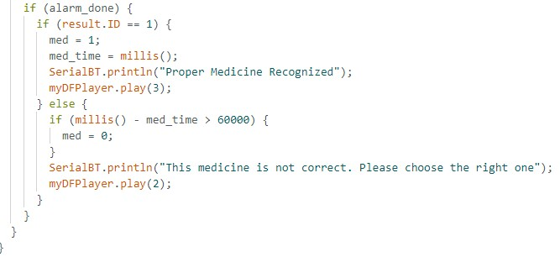
This code explains how the smart stick uses a HuskyLens camera to verify the correct medication after an alarm is triggered.It's activated only after the medication alarm has already sounded (_{if (alarm_done)}). The code then checks the ID of the object detected by the camera.
- If _{result.ID == 1}: The camera recognizes the correct medicine. The system sends a "Proper Medicine Recognized" message via Bluetooth and plays a success sound to confirm.
- If _{result.ID} is anything else: The camera detects the wrong medicine. It sends a "This medicine is not correct" message and plays an error sound to warn the user. This process ensures that the user is not only reminded to take their medicine but also guided to select the correct bottle, preventing potential errors.

Cost of the Prototype

Component | Estimated  Unit Cost  (USD) | Notes
ESP32 Microcontroller | $3.50 | The core of the robot, for processing data and controlling components.
MPU6050 | $2.50 | Motion and orientation detection sensor.
MAX30102 | $7.00 | Pulse Oximeter & Heart Rate Sensor.
OLED Display (0.91 inch) | $6.00 | A small screen for status and user feedback.
HuskyLens 2MP AI Camera | $40.00 | The most expensive component, for medicine recognition.
Sim800L Module | $6.00 | GSM Module for Emergency Calling
GY-NEO6MV2 GPS Module | $10.00 | Used for location tracking.
3D Printing Material | $10.00 | An estimate for the filament to print the casing
Total Estimated Prototype Cost | $82.00

Countries Around the World Who Already Implemented this Technology:

Japan
Japan is widely considered the global leader in elderly care robotics, driven by a rapidly aging population and a shortage of caregivers.Robots like Paro, a therapeutic robotic seal, are used in nursing homes to provide emotional comfort and reduce stress. Pepper, a humanoid robot, is used for social engagement, leading exercise classes, playing games, and providing medication reminders.Companies like Panasonic and Toyota are developing robots that assist with physical tasks, such as lifting and transferring elderly individuals, to reduce the physical strain on human caregivers. Exoskeletons like HAL (Hybrid Assistive Limb) are also in use to assist with mobility and rehabilitation.

Germany
With a significant caregiver shortage projected for the future, Germany is a key player. The Care-o-bot from Fraunhofer IPA is a well-known example designed to perform service tasks like serving food and drinks.

UK

Socially assistive robots are being trialed to engage older adults in physical activities recommended by the National Health Services (NHS). Research projects focus on creating robots that can lead exercises, provide encouragement, and offer feedback.

The Netherlands

The ZORA robot, a small humanoid, is used in many care homes across Belgium, the Netherlands, and France to lead group activities like dances and exercises.

The United States and North America
The North American market, particularly the U.S., holds the largest revenue share in the elder care assistive robotics industry.The ElliQ robot is a notable example from Intuition Robotics, an Israeli-based company, that has been distributed to elderly populations in New York. It provides conversational companionship, offers reminders, and helps users stay connected with family.

South Korea
Companies are developing AI robots with advanced language processing and emotional recognition capabilities to interact with individuals living with conditions like dementia.
Availability of Similar Healthcare Companion Robots in Bangladesh:
The global market for elderly care technology and healthcare companion robots is experiencing significant growth. The main drivers for this growth are the rapidly aging global population, the increasing demand for home-based care, and advancements in artificial intelligence (AI) and robotics.
Market Size: The global healthcare companion robot market was estimated at approximately $2.5 billion in 2025 and is projected to grow to over $12.3 billion by 2035, with a compound annual growth rate (CAGR) of approximately 16.8%

Availability in Bangladesh
● Focus on Rehabilitation: The primary investment in robotics for healthcare in Bangladesh so far has been in the rehabilitation sector. Recently, the country inaugurated its
first robotic rehabilitation center at Bangladesh Medical
University (BMU) in Dhaka | . This center is equipped
with
over 60 robots, with 22 powered by AI, to provide advanced physiotherapy and neurological rehabilitation services. This indicates a growing governmental and institutional interest in leveraging robotics for medical purposes.

● Emerging Health-Tech Startups: The local
health-tech landscape in Bangladesh is vibrant, but it is currently focused on digital health platforms, telemedicine, and remote patient monitoring rather than physical robotics. Startups like Praava Health, CMED Health, and Arogga are revolutionizing access to healthcare services through apps and online pharmacies. While these platforms use technology to improve health outcomes, they do not involve a physical robotic companion.

Future Improvements for our Project
1. Mobile App Integration:
- Real-time Health Tracking: The app would allow caregivers or family members to monitor the user's health metrics (e.g., heart rate, blood pressure, etc., depending on the sensors used) from anywhere. This provides peace of mind and allows for early intervention in case of a problem.
- Alerts and Notifications: Push notifications on the app would alert caregivers when a medicine is missed, a fall is detected, or if a health metric is out of the normal range.
- Medicine Management: Caregivers could use the app to schedule medicine reminders, manage the medicine database, and add new medications to the system remotely.
2. Smarter Medicine Recognition:
- Expanded Dataset: The current system can be improved by training the computer vision model with a much larger and more diverse dataset of medicines. This would include different brands, shapes, sizes, and colors of pills.
- Machine Learning Models: Moving from a simple object recognition model to a more advanced machine learning model could improve accuracy.
- OCR Integration: Integrating Optical Character Recognition (OCR) would allow the system to read the text on medicine bottles or packaging, providing an extra layer of verification.
4. Voice Assistant Feature:
- Simple Commands: Users could use simple voice commands like "remind me to take my medicine," "what time is my next dose?", or "call my son."
- Natural Language Processing (NLP): Developing a system with more advanced NLP would allow for a more conversational and natural interaction.
- Wake Word Detection: The voice assistant would be activated by a specific wake word, such as "Hello, CareCompanion."

Conclusion
The CareCompanion is a testament to the power of creative, problem-oriented engineering. It successfully transforms an urgent global health issue into a tangible, human-centric solution. The project's foundational strengths—its affordable cost, multi-functional design, and unique market position in Bangladesh—establish a strong base for future development. By systematically addressing its current limitations and strategically planning for the complexities of a commercial launch, the CareCompanion can evolve from a groundbreaking student prototype into an indispensable tool that not only improves the safety and independence of the elderly but also provides genuine peace of mind to their families and caregivers. Ultimately, the project is a beacon for a new era of compassionate technology, where innovation is a force for meaningful and positive change.

Resources
- https://pmc.ncbi.nlm.nih.gov/articles/ PMC3234383/
- https://drkumo.com/causes-impactsand-solutions-of-medication-noncompliance/
- https://drkumo.com/causes-impactsand-solutions-of-medication-noncompliance/
- https://cmed.com.bd/
- https://www.ilcjapan.org/studyE/doc/2018_1.pdf
- https://www.paroseal.co.uk/
- https://japanupclose.webjapan.org/techculture/t20240531_6.html
- https://www.cyberdyne.jp/english/products/HAL/
- https://citeseerx.ist.psu.edu/document?repid=rep1&type=pdf&doi=28eab592875c07bf2691bce7960985cc422a0365
- https://www.allaboutcircuits.com/electroniccomponents/datasheet/MPU-6050InvenSense/
- https://www.mouser.com/pdfDocs/ProductOverview_DFRobotGravity-MAX30102Heart-Rate-Oximeter-Sensor.pdf
- https://raw.githubusercontent.com/DFRobot/Wiki/master/SEN0305/res/HuskyLens%20WIKI%20Document.pdf
- https://www.robotics.org.za/DFR0299
- https://www.scribd.com/docume nt/378783749/NEO6MV2-Datasheet
- https://us.softbankrobotics.com/pepper

